**Vaya Play Tool**

**User Manual V1.0.0**

**1. Introduction**

Vaya Play Tool is designed for Discovery Test and LED output Test during manufacturing from Philips Solid-State Lighting Solutions.

Together with Smart Jack Pro, it can be set up a test and Discovery Test Station for Philips Vaya Series Lighting Fixture which compatible with RDM and DMX protocol.

This tool has below features:

1. Discovery the fixtures on the RS485 Bus and generate report for the fixtures successfully discovered.

2. Fixed Color test / Color Wash Effect / Channel Test

**2. Function Description**

**2.1 User Interface**

There are TWO tabs: one is for Discovery, the other is for LED test

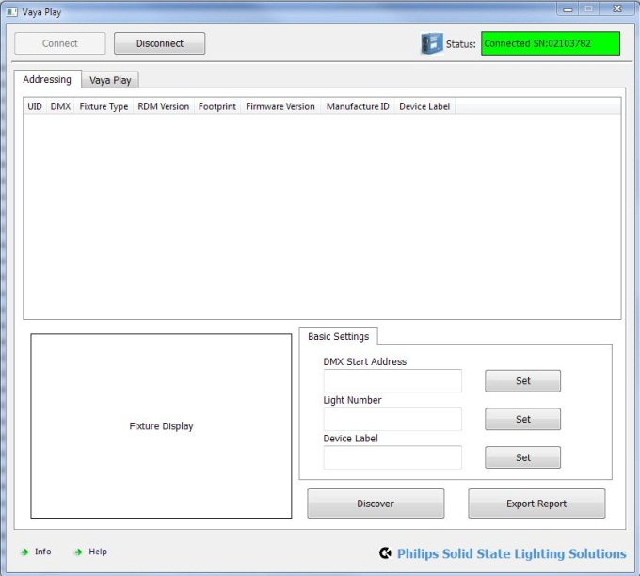 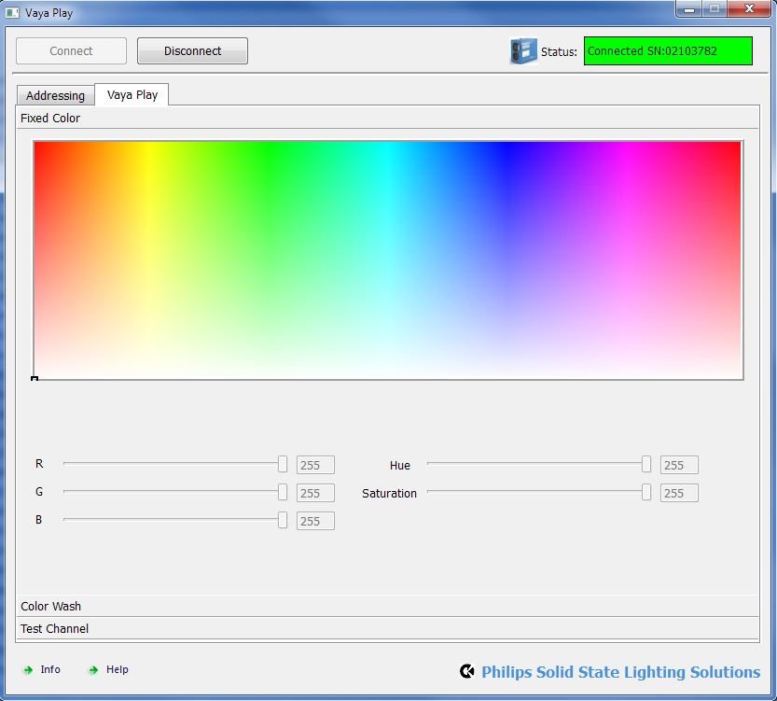

**2.2 Connect the Smart Jack Pro**

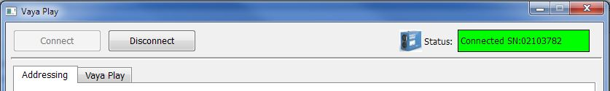

Click the Connect button, the software will try to connect the Smart Jack pro via Visual COM, so you have to install the FT245BM Driver before use. And the software only supports one device. Please don’t plug more than one SJP into the computer.

When successfully connected, the SJP logo will display colored and show the SJP Serial number in GREEN box.

Click the Disconnect button, the software will disconnect the device and logo will appear grey.

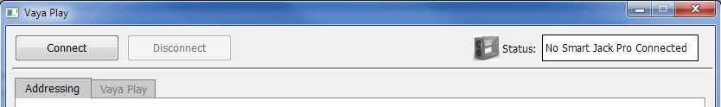

**2.3 Addressing**

Click the “Discover” button, the software will perform discovery process, after a few second, the table in the middle will list all the fixture information which connect on the bus.

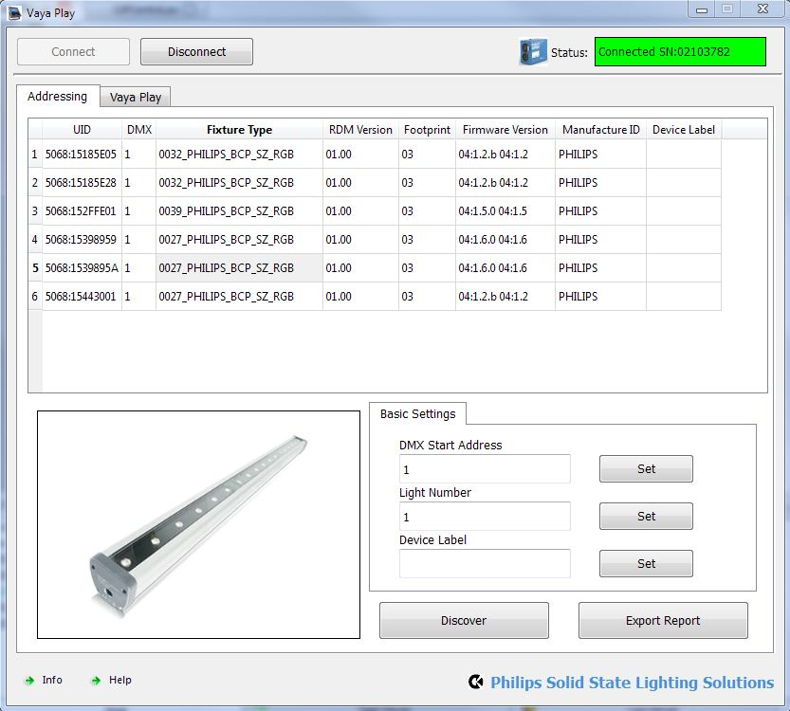

1. Click one of the row in the table, the corresponding fixture will blinking as Identify.

2. At “Basic Settings” tab, you can set the DMX Start Address, Light Number, Device Label

3. Click “Export Report”, the software will generate an excel file of the discover result.

**2.4 Play – Fixed Color**



You can click one point inside the Garmut area to let the LED output the target color.

**2.5 Play Wash**

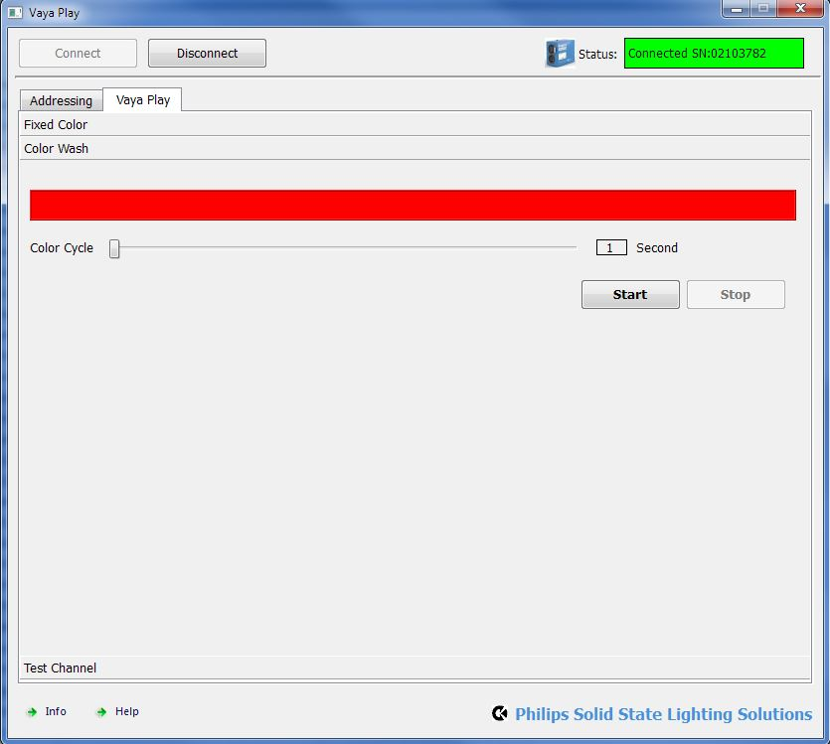

Click “Start” will begin the Color Wash Effect, and Click “Stop” will end the effect.

You can use the “Color Cycle” the change the time interval.

**2.6 Play – Test Channel**

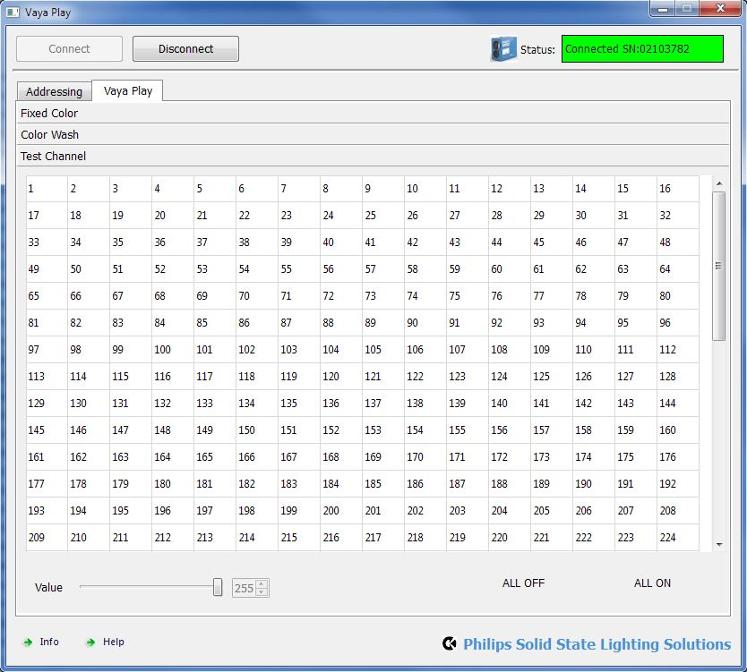

You can click the cell to turn on single or multiple channel.

**2.7 Info**

